Forensic Acquisition Report – Phase 2

By Wendel Jackson

Target System Description
The target system for this investigation is a Local Host System. The host system runs on Windows 11 and utilizes a controlled environment that simulates suspicious activity. The purpose of the target was to act as a test environment that simulates forensic data acquisition. To simulate an incident several commands were run in PowerShell and a folder containing suspicious files was created. This was done to mimic how real-world behaviors might be done and analyzed in an investigation.

Acquisition Plan
The objective of this was to collect volatile and non-volatile data from the target system. This was done through two methods:
- Disk Imaging
- Memory Acquisition
The tools used for this are FTK Imager for disk imaging and WinPmem for memory acquisition. Disk Imaging creates a copy of storage memory and memory acquisition captures volatile data.

Step By Step Acquisition Procedures

Disk Imaging Procedure
The Disk Imaging Procedure was done using FTK Imager. Then it was transferred to the Linux system and a sha256 has was generated prior to any other actions being carried out to the file:
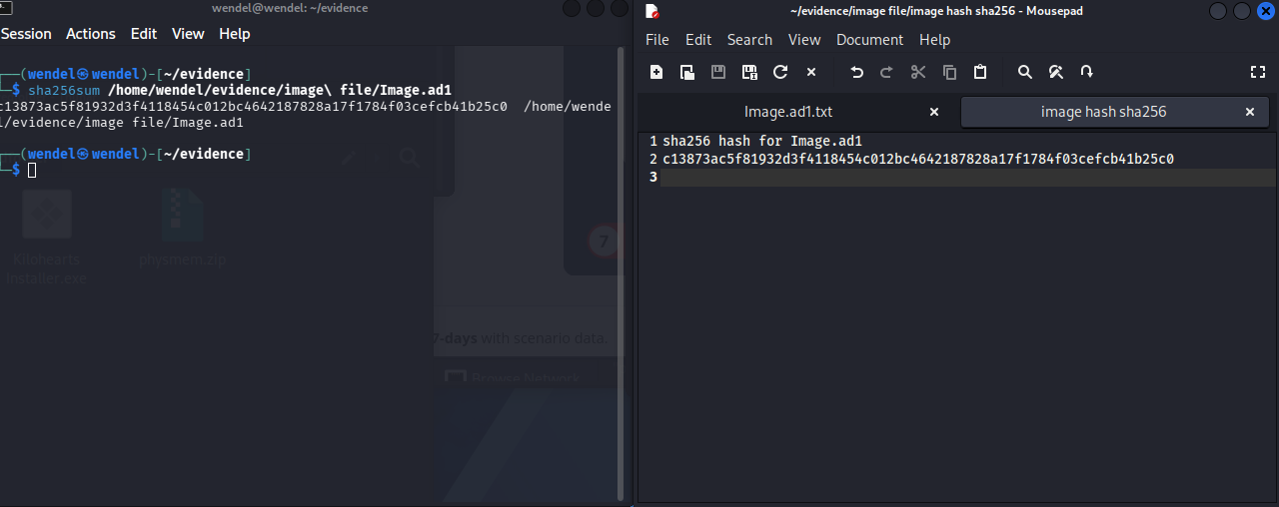
Image File: Image.ad1
Hash Value: c13873ac5f81932d3f4118454c012bc4642187827a1784f03cefcb41b25c0
File Size: 10.3 MB
Storage Location: /home/wendel/evidence

Memory Acquisition
Memory acquisition was done on the Windows local host and capture volatile data using the WinPMEM tool.
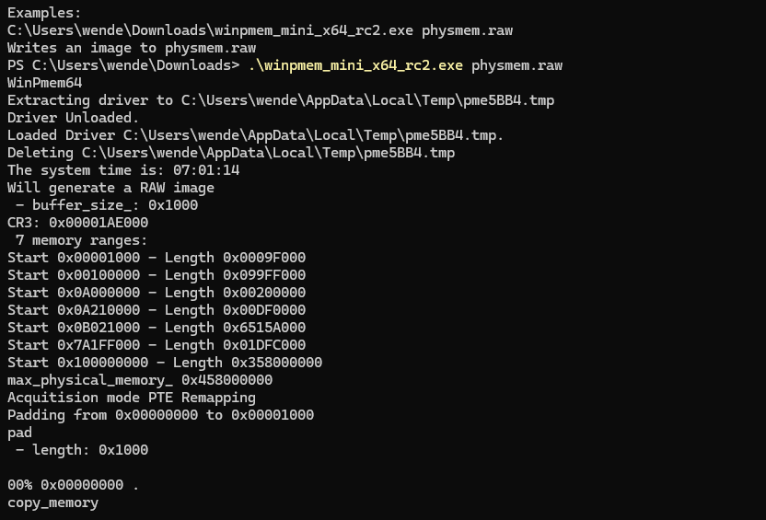
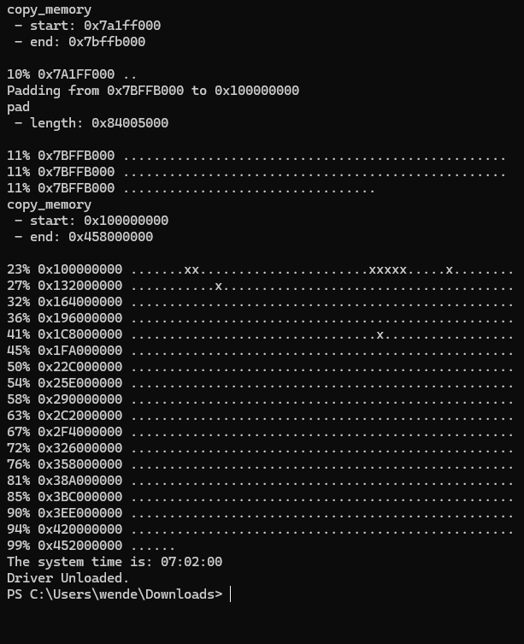
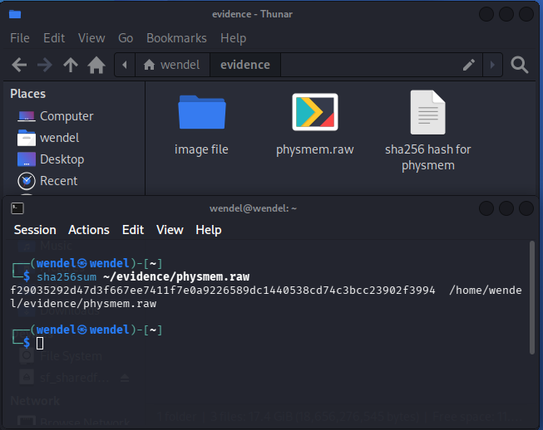 Memory Dump File: physmem.raw
Hash Value: f29035292d47d3f667ee7411f7e0a9226589dc1440538cd74c3bcc23902f3994
File Size: 17.4 GB
Storage Location: /home/wendel/evidence/physmem.raw

Challenges and Mitigation
Some of the challenges I faced were:
- Storage Limitations: Full disk imaging wasn’t possible due to a lack of storage so I created an image of the specific folder containing all the suspicious information.
- File Transfer: Moving files between the host computer and the virtual machine required me to create a shared folder.

Chains of Custody

Evidence #1
- Evidence ID: 1
- Description: Disk Image
- Date/Time Acquired 4/21/26 3:08 PM EST
- Hash: c13873ac5f81932d3f4118454c012bc4642187827a1784f03cefcb41b25c0
- Storage Location: /home/wendel/evidence

Evidence #2
- Evidence ID: 2
- Description: Memory Dump
- Date/Time Acquired 4/21/26 3:02 AM EST
- Hash: f29035292d47d3f667ee7411f7e0a9226589dc1440538cd74c3bcc23902f3994
- Storage Location: /home/wendel/evidence/physmem.raw

Summary
This phase provides hands-on experience with real forensic data analysis techniques. Using disk imaging and memory dump tools showcased how investigators collect both types of memory. One of the major takeaways from this phase was the process of verifying data integrity and the real-world limitations one may face, such as limited storage. This includes labeling the date and time the evidence was acquired, the location of said data, and the hash.

